**Analysis on Sustainable Development Goals (SDGs) Indicators**

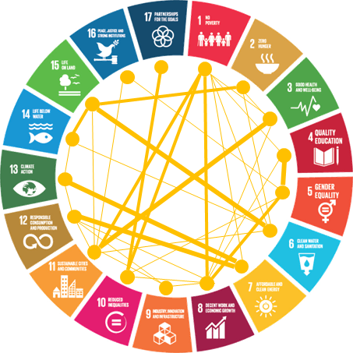

**Historical preview**

-In June 1992, at the Earth Summit in Rio de Janeiro, Brazil, more than 178 countries adopted Agenda 21, a comprehensive plan of action to build a global partnership for sustainable development to improve human lives and protect the environment.

-Member States unanimously adopted the Millennium Declaration at the Millennium Summit in September 2000 at UN Headquarters in New York. The Summit led to the elaboration of eight Millennium Development Goals (MDGs) to reduce extreme poverty by 2015.

-The Johannesburg Declaration on Sustainable Development and the Plan of Implementation, adopted at the World Summit on Sustainable Development in South Africa in 2002, reaffirmed the global community's commitments to poverty eradication and the environment, and built on Agenda 21 and the Millennium Declaration by including more emphasis on multilateral partnerships.

-At the United Nations Conference on Sustainable Development (Rio+20) in Rio de Janeiro, Brazil, in June 2012, Member States adopted the outcome document "The Future We Want" in which they decided, inter alia, to launch a process to develop a set of SDGs to build upon the MDGs and to establish the UN High-level Political Forum on Sustainable Development. The Rio +20 outcome also contained other measures for implementing sustainable development, including mandates for future programmes of work in development financing, small island developing states and more.

-In 2013, the General Assembly set up a 30-member Open Working Group to develop a proposal on the SDGs.

-In January 2015, the General Assembly began the negotiation process on the post-2015 development agenda. The process culminated in the subsequent adoption of the 2030 Agenda for Sustainable Development, with 17 SDGs at its core, at the UN Sustainable Development Summit in September 2015.

-2015 was a landmark year for multilateralism and international policy shaping, with the adoption of several major agreements:

1- Sendai Framework for Disaster Risk Reduction (March 2015)

2- Addis Ababa Action Agenda on Financing for Development (July 2015)

3-Transforming our world: the 2030 Agenda for Sustainable Development with its 17 SDGs was adopted at the UN Sustainable Development Summit in New York in September 2015.[¶](https://kkb-production.jupyter-proxy.kaggle.net/static/dist/jupyterlab/jupyterlab-index-2cbc9438077c9bc719d3.html?session=eyJhbGciOiJub25lIiwidHlwIjoiSldUIn0..&lsp=true#3-Transforming-our-world:-the-2030-Agenda-for-Sustainable-Development-with-its-17-SDGs-was-adopted-at-the-UN-Sustainable-Development-Summit-in-New-York-in-September-2015.)

4- Paris Agreement on Climate Change (December 2015)

-Now, the annual High-level Political Forum on Sustainable Development serves as the central UN platform for the follow-up and review of the SDGs.

In General

SDG indicators: The Sustainable Development Goals (SDGs) are a collection of 17 goals designed to monitor progress to various sustainability targets defined by the United Nations 2030 agenda (end of poverty, zero hunger, health & wellness, quality education, gender equality, clean water and sanitation, affordable and non-polluting energy, decent work and economic growth, industry, innovation and infrastructure, reduction of inequalities, sustainable cities and communities, responsible production and consumption, climate action, submarine life, life of terrestrial ecosystems, peace, justice and strong institutions and partnerships to achieve goals.

The purpose of this report is to analyze the information available from the World Bank and the UN in order to establish priorities in the matter of financing projects carried out by the World Bank.

After collecting indicators, cleaning the data and merged all the tables we can proceed to make a scientific analysis and visualization.

Analysis of the relationship between the indicators

The first indicator analized is the human development index wich measures the average achievements in a country in three basic dimensions of human development: a long and healthy life, access to knowledge and a decent standard of living.

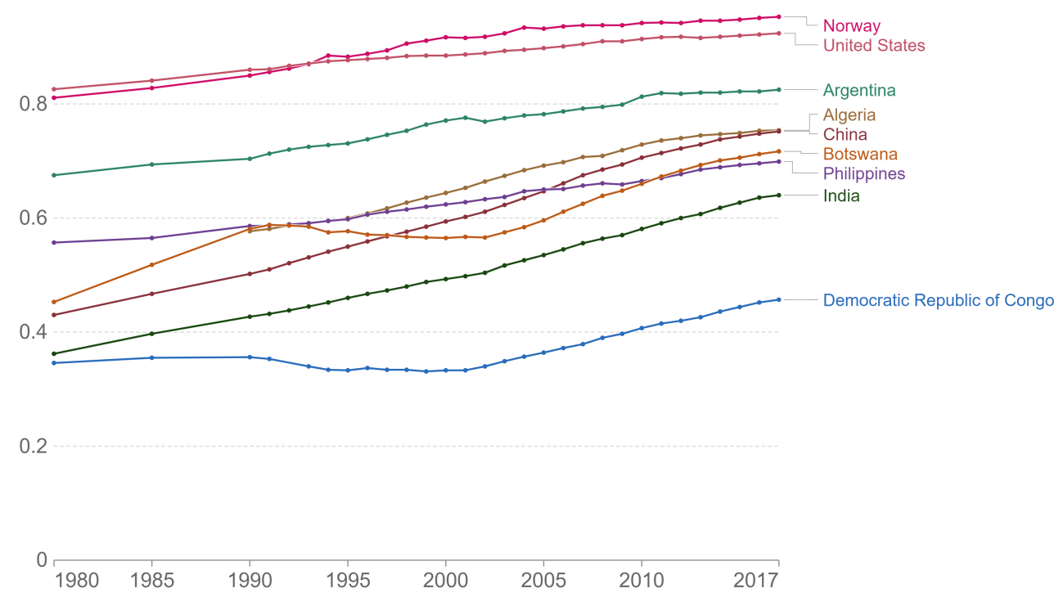

As can be seen in Argentina there was a growth since 1980 following the majority of the countries analyzed. The following graph also demonstrates the high density of the indicator.

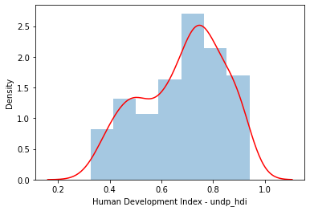

The human development of the countries is related to renewable energies, but as can be seen in the following graph, there are countries with a large population and a high human development index but with traditional energies.

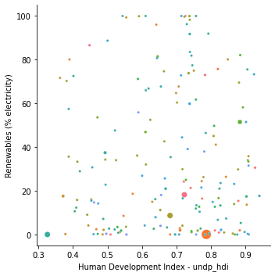

Comparing the population below the poverty line with the percentage of renewable energy we can see a high correlation.

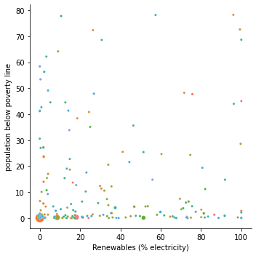

And there is also a high correlation between the population below the poverty line and the number of hectares per person of arable land, as can be seen in the following graph.

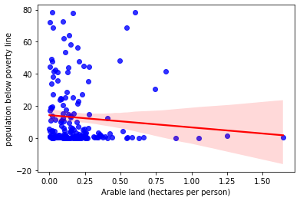

Regarding the poverty line, it can be observed that the largest amount of the world population is above the poverty line.

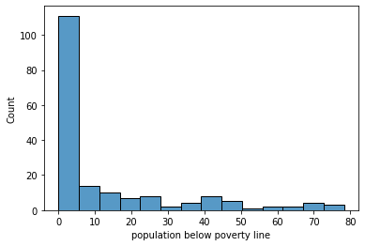

On the other hand, it is interesting to observe that the percentage of arable land is not affected by the extraction of water per person. 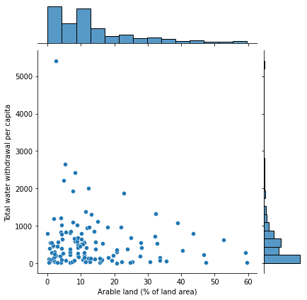

Relationships between indicators.

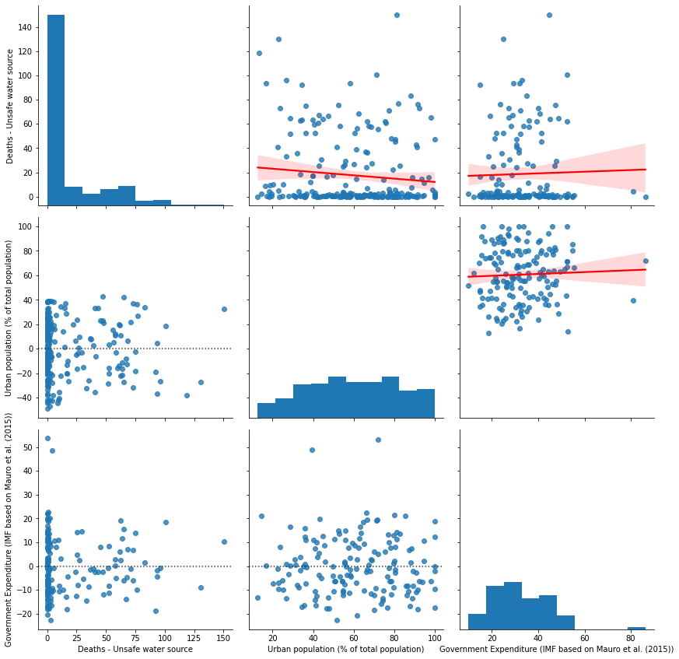

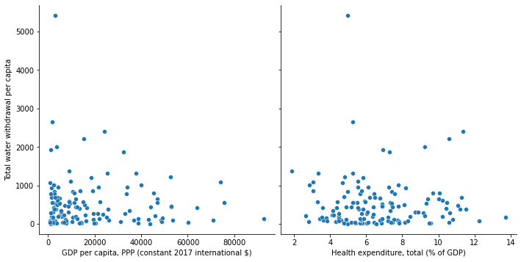

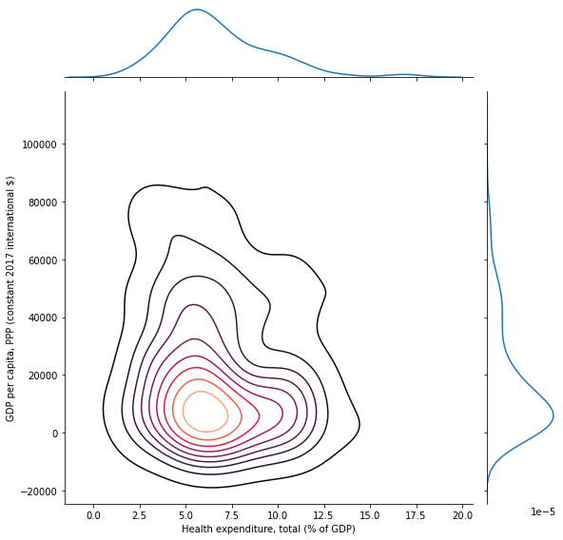

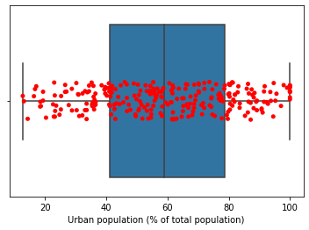

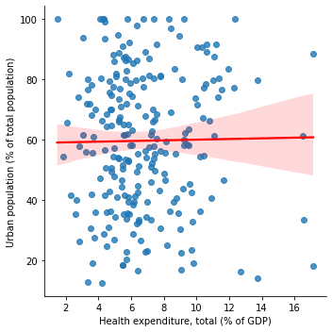

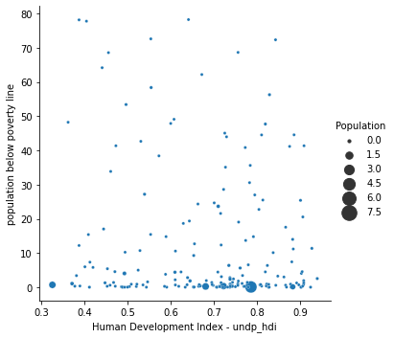

As can be seen from the data analyzed, the growth of the human development index appears as essential in all the analyses, demonstrating that human capital is the basis of sustainable development and continuous improvement. Projects aimed at integration between genders in workplaces, training in competitive and new jobs and education in general should be the basis of any financing program.